Casting Your Cares Bookmark grade 4-7

Supplied needed
- White paper for your drawing
- Cardboard
- Glue/Pritt
- Colour pencils or Crayons or Roll ups
- Scissor
- Broad clear Tape

Steps
1
Choose suitable paper. Select a heavy cardstock-like paper to act as the support for your bookmark, and then choose an additional image or pattern to glue over the top.
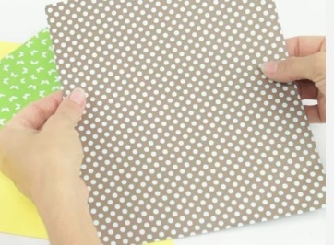

2
Colour in your Image. Print out supplied printable or draw your own Picture and begin to colour-Dont be afraid use Bright Colours.

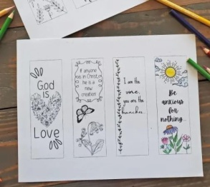
3
Cut the paper. Then cut out the bookmark or picture you have drawn then Cut the cardboard same size as picture.

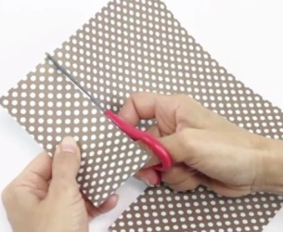

4
Glue /Stick. Using the images you made or printable you coloured and cut , glue them onto the cardboard cut out.
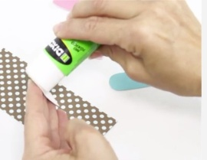
5
Cover your bookmark. In order to protect the paper from becoming frayed or damaged, add a protective covering to your bookmark.
- You can also create this effect by using wide packing tape in an even strip on both sides of your bookmark.

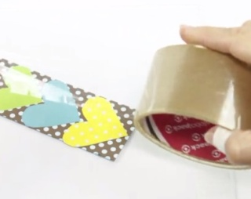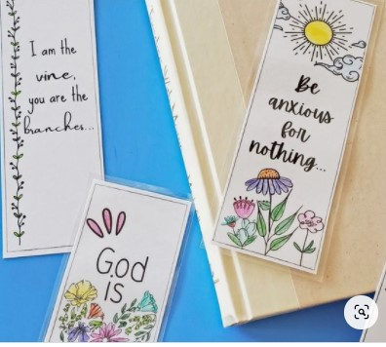

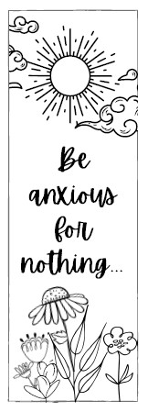
Printable for casting your care bookmarker grade 4-7

