SLAYING GIANTS – DON’T GIVE UP!
Welcoming Question: What is something you never, ever get tired of doing?

Over the last 2 weeks we’ve learnt that the giant of fear can be conquered when we put our trust in Jesus and courageously face the things that make us afraid & courage sometimes looks like doing the right thing – even when everyone else is not; just like David fighting Goliath with his few stones and a sling.

This week we are going to talk about not giving up even when we feel like quitting.
Take a moment & share if there was anything that happened this week where you wanted to quit / give up / not finish.
Game ideas to do at home / kids church to help build perseverance:
- Ring toss: set up a ring toss set OR if you don’t have one, cut out the center of paper plates and toss them at cups or mason jars.
- Water bottle flipping
- Minute 2 win it games
- Basketball / netball shots in the net

God gives us the courage to never give up! Galations 6: 9 “ So let’s not get tired of doing what is good. At just the right time we will reap a harvest of blessing if we don’t give up.”
Chat points with mom / dad:
- How do you feel when you keep doing the right thing, but no one notices?
- What are some truth declarations you can speak over yourself when you feel like quitting?

Action Step: Think about your week at school or your friends – what good thing can you keep doing even if you’re tired of doing it?
Does it reflect the love of Jesus to those around you?
Pray together: God, please give us courage to keep doing what’s right, even when it seems nothing around us is going well. In Jesus’ name, amen.

Craft Activities:
Noah, the dude who built the ark, had some great courage! Watch this Superbook clip with your family: https://youtu.be/t1p5ocaJzTM

Find some craft activities below in appropriate age groups:

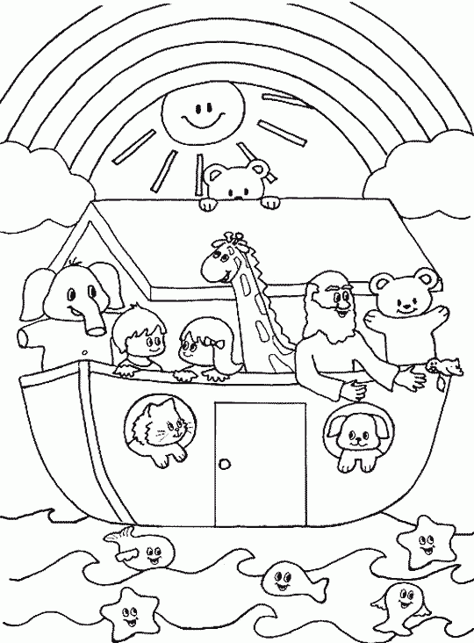
Pre-school
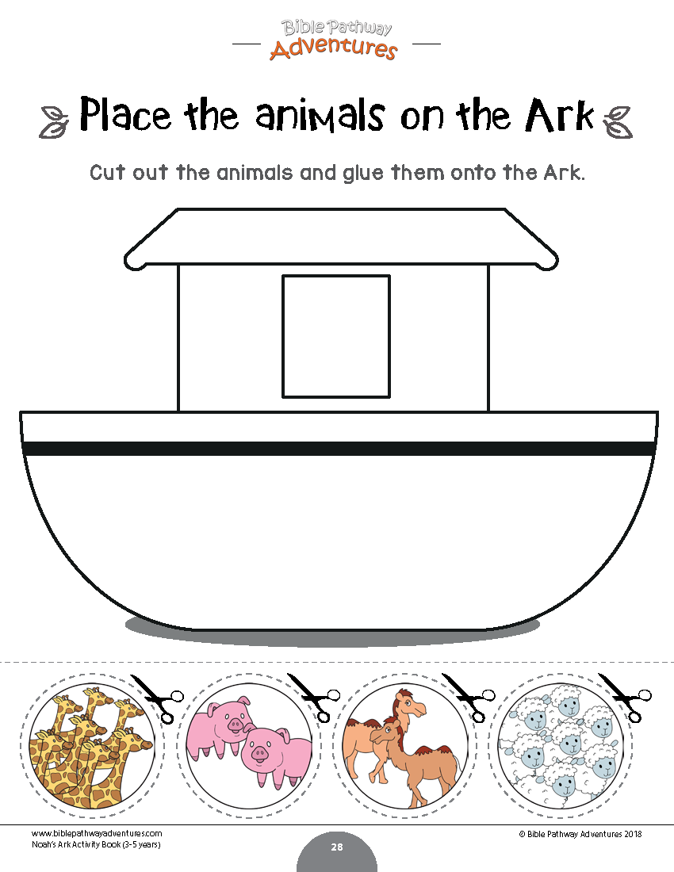
Gr1-3
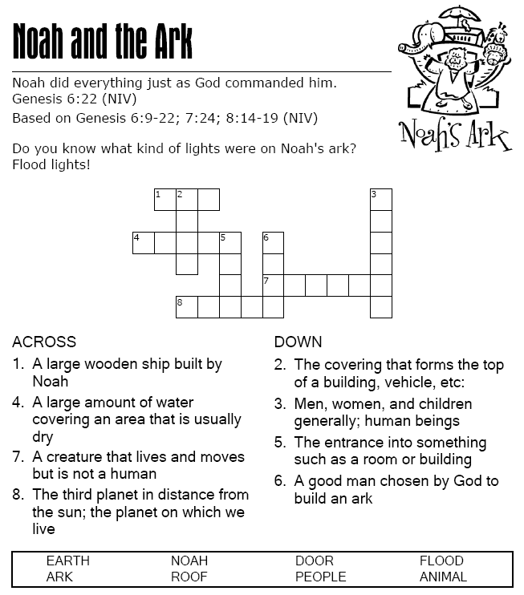
Gr4-7

