Worry Jar grade 1-3
Suppliers you need
- A jar with a lid
- Paper or ice cream stick
- Permanent marker
- Ribbon / stickers decoration
- Printable scripture
- Pritt or glue
- Scissor

How to make it
Step 1 : Cut out printable and stick onto the jar and decorate jar with ribbon and stickers of your choice .
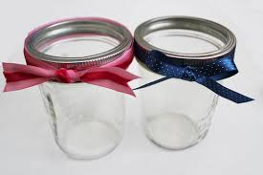

Step 2 : Ask kids to write down they worry or cares on ice cream stick or pieces of paper .
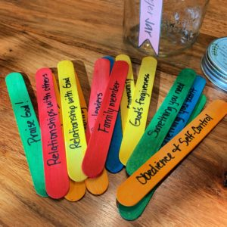

Step 3 : Ask each child to place they worry / care into the jar as it allow them to cast their cares onto Jesus .
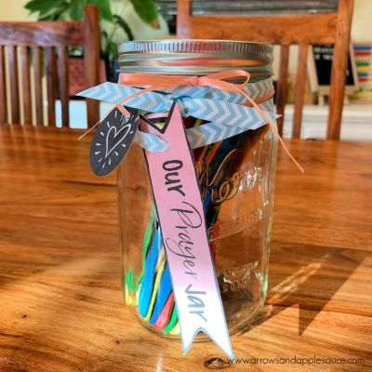
Printable for Worry Jar – grade 1-3
