WHAT’S THE STORY, YO?
THE WISE MEN’S STORY

PRAISE & WORSHIP: Leaders choose 1 song for worship time
Intro: Today, we are learning about visitors from the East who followed a very bright light to a very surprising end. The Wise Men were royal astrologers or magi which means that they studied the stars. They were men of great learning, and they followed the patterns of the stars religiously.

Watch: What are stars? https://youtu.be/ZrS3Ye8p61Y
Read: Matthew 2:1-12
OR
Watch: The Wise Men https://youtu.be/22SMUUMsx0o
The Wise Men could see the star and follow it to Jesus, but there was no way of knowing how incredible Jesus’ coming really was!
Jesus’ coming not only changed the lives of Mary and Joseph, the Shepherds, and the Wise Men … it also is changing our lives each and every day!

Anchor verse: “For to us a child is born, to us a son is given;
and the government shall be upon his shoulder,
and his name shall be called Wonderful Counselor,
Mighty God, Everlasting Father, Prince of Peace.” - Isaiah 9:6, NLT

Game: Christmas Pictionary
Children take turns drawing the objects for others to guess. The child doing the drawing must remain silent so as not to give extra clues. Whoever guesses it correctly gets to draw next.
- Christmas tree
- Shepherd
- Manger
- Snowman
- Present
- Star
- Candy cane

OR

Craft activity: How to make a cardboard telescope
https://youtu.be/9QwwhTu5N-I

Activity: Hidden card – look for the hidden items in the picture below:
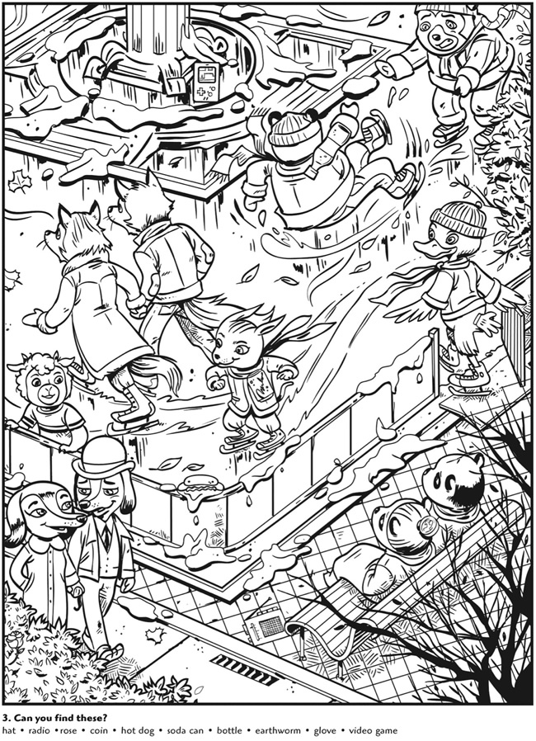

CAN YOU FIND THESE HIDDEN ITEMS?
HAT RADIO COIN HOT DOG SODA CAN
BOTTLE EARTHWORM GLOVE VIDEO GAME

