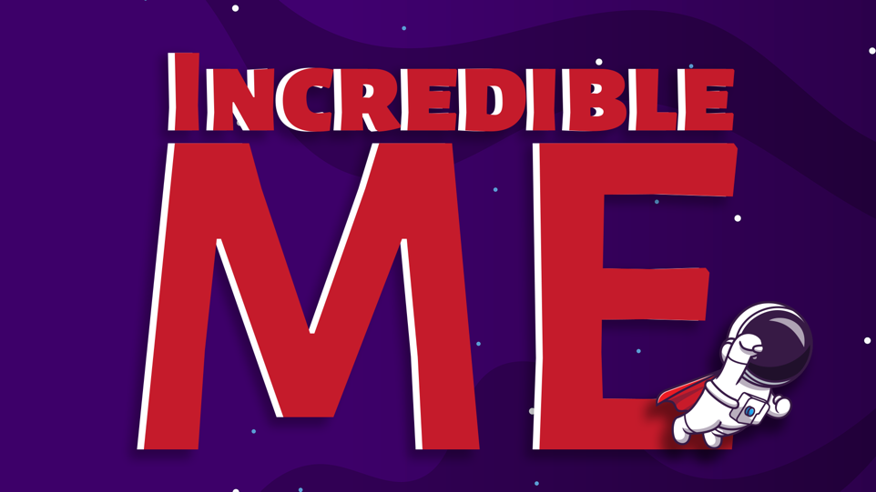
Week 2 – God Made Me
Aim: To teach the children that God made us just the way we are on purpose.
Scripture Reference: Genesis 2
Memory Verse: Ephesians 2:10 “For we are God’s masterpieces. He has created us anew in Christ Jesus, so we can do the good things he planned for us long ago.”

Intro:
Welcome to the Greatest Hour of the Week. We have been looking forward to spending this hour with you all week! Do you know why we were so excited to spend time with you today? (Allow the children to respond) That’s right! Because you are incredible kids!
Do you remember what makes you so incredible? (Allow the children to respond) That’s right! You are incredible because you are God’s children! He made you and He loves you and that makes you pretty incredible.
Last week we heard the amazing story of how God created the world and everything in it. He just spoke, and things appeared out of nothing. Isn’t that incredible? We discovered that God made everything just the way it is on purpose because God doesn’t make mistakes.
First God made light. Then He made the sea and sky. Next God made land. He filled the land with trees and plants and animals. God put the sun, moon and stars in the sky and He filled it with beautiful birds he also filled the sea with all kinds of fish.
But God wasn’t finished yet, He saved the best part of his creation for last and that is where our story begins today.

Note: For this story, you will need two large cut out of bodies (Adam and Eve) and eyes, ears, a nose, a mouth, and a heart that can be added as you tell the story.

Story:
When God looked at everything, he had made he said, ‘You’re good!’ and it was.
But God wasn’t finished! He had a shining dream in his heart. He would make people share the beautiful world he had made. They would be his children, and the world would be their perfect home.
So, God took some clay from the ground and made the shape of a man. Then He breathed gently into the shape. When the man opened his eyes the first thing he saw was God’s face, smiling at him. God called the man Adam.
God had made the man to keep Him company and look after the world.
One at a time, God brought the animals to Adam and asked him to give each one a name.
The one with the big long trunk he called…. (Allow the children to respond) That’s right! "Elephant", and the one with the black and orange stripes he called "Tiger", the one with the sharp spikey quills he called "Porcupine".
But God felt sorry for Adam. "None of these animals are really like him," thought God, "he needs someone to share his life with. Someone who cares for him and who he can care for."
That night, God made Adam fall into a deep sleep. While he was sleeping, God took a rib from Adam's side and made a woman. When Adam woke up the first thing he saw was Eve, his wife. Adam was so happy.
God made Adam and Eve like him. They were perfect and He loved them because they were His.
Let’s look at some of the wonderful special things God did when he made Adam and Eve.
He gave them eyes to see all the beautiful things he had created
(Invite a boy and a girl to come up and give Adam and Eve eyes)
He gave them ears to hear the songs of the birds, the sound of the ocean, and most important so they could hear God say ‘I love you.
(Invite a boy and a girl to come up and give Adam and Eve ears)
He gave them mouths to speak, so they could share their hopes and dreams with God and each other.
(Invite a boy and a girl to come up and give Adam and Eve mouths)
He gave them noses to smell, so they could tell difference between a flower and a skunk!
(Invite a boy and a girl to come up and give Adam and Eve noses)
The most important thing God gave his special children was their hearts! Hearts so they could love God and each other.
When God looked at the Adam and Eve, his heart was filled with love for them. He loved them because they were His!
The same God that made Adam and Eve made you and me too! He gave us eyes to see (point to your eyes), ears to hear (point to your ears), mouths to speak (point to your mouth), noses to smell (point to your nose) and most importantly hearts to love (Place your hands over your heart).
God made you just the way you are on purpose and God never makes mistakes.
Each one of you is perfectly… YOU! You’re perfect because you are His!
Can you say that to me? ‘I am perfect because I am His!’ (Point up when you say His) Repeat a few times.
Please don’t ever forget that!
Let’s Pray: Dear God, thank you for making me just the way I am on purpose. Thank you for my eyes, my ears, my nose, and my mouth, and thank you most of all for my heart! I love you, God. Amen

Craft: God Made Me Self Portrait
Children will each get a piece of white card with a heading God made me. There will be paint available for them to finger paint a self-portrait of themselves.

