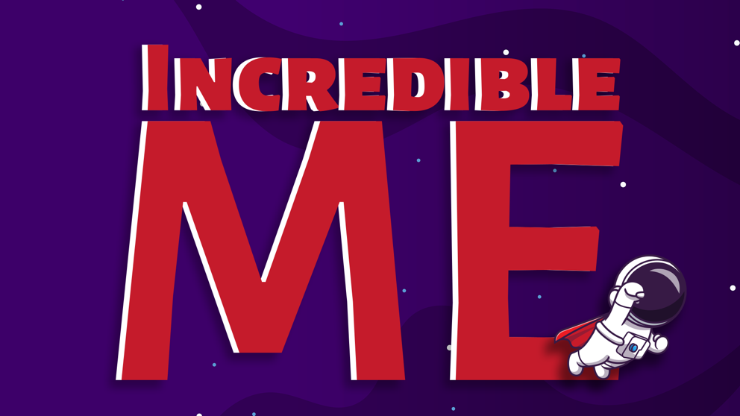

Week 3 – God Loves Me
Aim: To teach the children that God loves you, and nothing you will ever do will change that.
Scripture Reference: Genesis 3
Memory Verse: Ephesians 2:10 “For we God’s masterpiece. He has created us anew in Christ Jesus, so we can do the good things he planned for us long ago.’’
Intro:
Welcome to kid’s church. We are so happy to see all of you today. We have been so excited about spending this time with you. Why do we love spending time you? (Allow the children to respond) That’s right! Because you are incredible kids!
Do you remember what makes you so incredible? (Allow the children to respond) That’s right! You are incredible because you are God’s children! He made you and He love you and that makes you pretty incredible.
Last week we heard how God after he created the world and everything in it, made a man out of clay and breathed life into him. What did God call the man? (Allow the children to respond) That’s right. God called the man Adam.
God didn’t want Adam to be lonely, so he made a woman to be his friend and he called her… (Allow the children to respond) That’s right! He called her Eve
When God looked at Adam and Eve, his heart was filled with love for them. He loved them because they were His!
The same God that made Adam and Eve made you and me too! He made each and every one of us perfectly! We are perfect because we are His!
And that is where our story begins today.

Video:
(Adapted from The Terrible Lie – Jesus Storybook Bible by Sally Lloyd-Jones)
https://www.youtube.com/watch?v=-sZPlFNbktM
Tell the children they must listen carefully because at the end there will be some questions.
“Turn your listening ears on and watch carefully”
Questions for after the clip:
Was God happy about what Adam and Eve had done? Absolutely NOT!
What do you think was the consequence of their actions? Yes! They had to leave the beautiful garden that had been their home
BUT here’s the good news God didn’t stop loving them! He couldn’t, they were his children and nothing they could ever do would make God stop loving them.
Like Adam and Eve, we all make mistakes and do things we know we shouldn’t. When we do things wrong, there might be consequences to our actions, but here is the truth….
Nothing you will ever do will make God stop loving you.
Can you say that to me? ‘Nothing I will ever do will make God stop loving me!’ Repeat a few times.
Let’s Pray: Dear God, thank you for loving me. Thank you for loving me even when I make mistakes and do things, I know I shouldn’t. Please help me to remember that nothing I will ever do will change your love for me. I love you God. Amen.
Craft:


