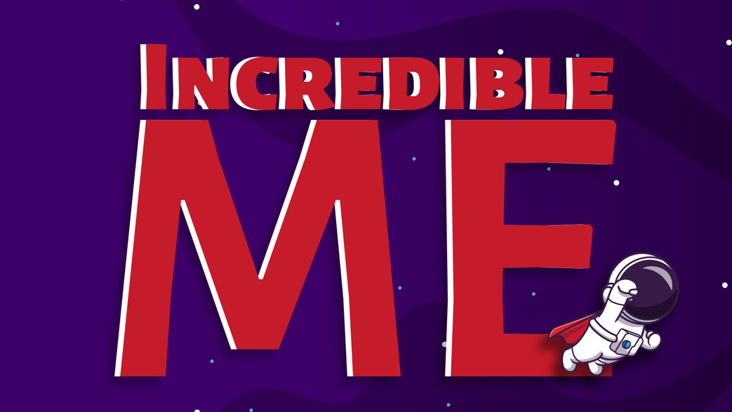

WEEK 4 – GOD’S UMBRELLA – NOTHING SEPARATES US
Series Aim: To help the kids discover their identity in Christ and to encourage the children to find love, value, and purpose in God and not in the people or things of this world.
Series Memory Verse: Ephesians 2:10 “For we God’s masterpiece. He has created us anew in Christ Jesus, so we can do the good things he planned for us long ago.
Intro and Recap
So far, we have spoken about our God who is love, who created us because he wanted to be in a loving relationship with us so that we feel safe and secure. God also gave us the freedom of choice gift where we choose to either trust Him or trust ourselves.
Then we looked at how the snake known as the Devil that wanted to pull us away from this safe love relationship with God, he wanted us to doubt God, he told us lies about what God had said and he tempted us with the idea of trusting in ourselves instead of trusting in God. Adam and Eve disobeyed God and we saw how they felt shame resulting in them wanting to run, hide and cover up their mess. But God came looking for them because he loves us despite our mess. He has a better way of fixing our messes than we do.
However, we all do have to face the consequences of the choices we make. Last week we looked at the story of the woman at the well, who had made some big messes in her life. When Jesus met her, he could see that her heart was thirsty for the love of God, but that she had been trying to quench that thirst in the wrong places. We learnt that we all can choose to get the thirsts of our heart met in God or things of this world. It is our free choice.

Teaching:
Play the song based on Romans 8:39
https://www.youtube.com/watch?v=AlKNh0Y2DJ8

Today we are going to end this series speaking about the truth that nothing can separate us from the love of God.
If you remember back to the first week when we heard the story about Adam and Eve and the mess, they made by not listening to what God had said. When they realized they had made a big mistake we spoke about how they ran, they hid, and they covered by.
What Adam and Eve tried to cover themselves up with was fig leaves from a tree? Now I don’t know if you have ever tried to make clothes from leaves before – but I can imagine that firstly it must have been quite itchy and scratchy and not very strong. If the wind had to start blowing it could have easily blown their clothes right off.
The point of this story is God wants us to understand that we are not very good at fixing our messes and His heart wants to tell us that when we make a mess the very best thing, we can do is bring our mess to Him. God made clothes from animal skins for Adam and Eve. He made a covering for their shame that was way better then what they tried to do.
God has a covering for us too. His covering is the blood of Jesus who died on the cross to cover up our mess once and for all. This includes the messes we have made in the past, the messes we make each day now and the messes we are still going to make in the future.
He knows them all - this is why he doesn’t want us to feel ashamed or embarrassed of our mistakes and messes. He wants us to know that He is a safe space we can bring our messes and mistakes too. He will always love us – no matter what mess we make in life. Because as Romans 8:39 says – that NOTHING can separate us from God’s love. Say to the person next to you NOTHING YOU DO CAN MAKE GOD STOP LOVING YOU.
Psalm 46:1 says “ God is a safe place to hide, ready to help when we need him.”

Wrap Up and Conclusion:
What do you use when its raining? That’s right an umbrella. And how does an umbrella help you in the rain? Yes, is protects you, it keeps you safe, it keeps you dry and warm. Just like an umbrella in the rain God is like our umbrella that we can hide under from the hurts and pains of life. In life there are going to be things that we face that are tough.
- Sometimes our moms or dads let us down, they also mess up and their mess hurts us.
- Sometimes our friends let us down, they also mess up and their mess hurts us.
- Sometimes we mess up and we have to face the pain of our choices, and this hurts us.
We may feel disappointed, rejected, angry, abandoned, used, misunderstood, frustrated, left out, or hurt.... in God we all have a safe space to take our hearts when they feel like this – and that is to the unchanging, all loving covering of God.

Closing Small Group: Prayer time
Ask the kids if there is anything they want to pray for. Pray into their identities. If there is anyone they want to pray for or forgive give them the space to do that. Thank God for each of them.

