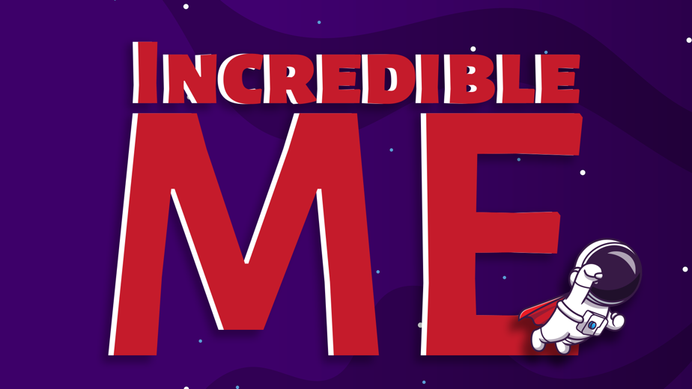

WEEK 3 – WHAT DO I DO NOW? WE HAVE A CHOICE
Series Aim: To help the kids discover their identity in Christ and to encourage the children to find love, value, and purpose in God and not in the people or things of this world.
Series Memory Verse: Ephesians 2:10 “For we are God’s masterpieces. He has created us anew in Christ Jesus, so we can do the good things he planned for us long ago.’’
Opening Activity: Ask the kids how their week was. Then to open the lesson ask the kids what do you love to drink when you are really thirsty? Is there something that you can drink that just doesn’t take your thirst away no matter how much of it you drink? – Can also play a drinking game here for fun!

Play Clip – Samaritan woman at the well from The Chosen
https://www.youtube.com/watch?v=f_UNAQFRhBY
In John Chapter 4 there is a story about a woman who had made a very very big mess in her life. She had been married 5 times and now was living with a man she wasn’t even married to. She was so ashamed, so embarrassed, of her mess that when she used to go to the well each day to get water to drink, she would go at lunch time – when it was the hottest time of the day – just so she wouldn’t have to see anyone else. She feared other people seeing her because she knew she had made some bad choices in her life.
One day Jesus met her at the well at lunch time in the heat of the day – she was a little shocked that he even wanted to talk to her. She felt like she was not good enough for him to speak to her.
Jesus then started to talk to her about water. He spoke about two different types of water.
One water is the water we drink when we are thirsty. The other water is the water our hearts need when it is thirsty for God’s love. Jesus could see that this lady by the well was very thirsty in her heart for God’s love. However, she has been trying to find God’s love in all the wrong places. She had thought that all the relationships she had been in would satisfy the thirst for God’s love in her heart. Jesus then tells her that if she drinks the water He gives her – she will not be thirsty in her heart anymore.
Wrap Up and Conclusion
Ok guys so we know that Adam and Eve felt safe and confident at first because...
- They were loved by God
- They had a purpose with God
- They knew their value through their relationship with God and others.
But then they messed up and the consequence of the mess that Adam and Eve made is that WE are all still looking for love, purpose, and value, (We want to know we are loved, that we have something special to do on earth and that we are important and good enough). Because we all no longer are born walking and talking with God like Adam and Eve were made, we are born with this thirst (this desire, this need deep inside our hearts and spirits), for love, purpose, and value and now we have a choice on HOW we get that thirst met?
You see God knows we all have this thirst in our hearts. The thirst is for God’s love, knowing our purpose in him and knowing our value in him. God wants us to drink from the fountain of living water that He has for us. He made the thirst in us – only he can fully meet this thirst.
However, we have a choice – we can choose to trust God and put our hand in His and choose to walk in a trusting relationship with Him. Or we can choose to do things our own way.
We can choose to try get the thirsts of our heart met in our own ways.
You see the truth is God wants to us enjoy this world he made. He wants us to enjoy our friends & family, enjoy our talents, enjoy our achievements and blessings – but he doesn’t want these things quench the thirst of our heart. Only He can do that. The things of this world will only leave us feeling thirsty again. When we have a right relationship with God where we walk and talk with Him, where we feel safe enough to bring our messes to Him, where we share our successes with Him, then we live safe and secure lives with no need to hide or feel ashamed because we know we are daughters and sons of the king. But this is our choice. What are you going to choose?

Closing Small Group:
Leading Questions:
- Say: We can try get our value, and feel important, through performance (by always trying to be the best or be first) – by believing that we are only good enough or only important when we are best or first. But what happens when we fail? When we come last, and we are not the best? What does that mean for us? Allow kids to respond, then ask – does this mean we are a failure too? Reassure the kids no, they are not failures, they must know they have value, and they are important no matter what they do or don’t do or accomplish or don’t accomplish.

- Say: We can try get love through acceptance of others – by doing anything to make sure we fit in. But what happens if people want us to do things that are wrong? Allow kids to respond... – or what happens if people still don’t accept us – does this mean we are unloveable? Reassure the kids no, God loves them, and true love is not based on things we do or don’t do we are loved regardless of what we do, we are loved because of who we are.

JESUS SATISFIES THE THIRSTS OF MY HEART
Craft:
