
WEEK 7 – I AM Courageous
Series Aim: As we admire David's heroic courage, we need to remember that it was the God of Israel who enabled him to overcome Goliath. When we trust in Him, Jesus can enable us to overcome our giants too.
Scripture Reference: 1 Corinthians 16:13
‘’Be on guard. Stand firm in the faith. Be courageous. Be strong ‘’
Ice breaker:
ASK: It may have been scary for David to fight Goliath, but he knew God was with him, so he did it. Think of something you know you need to do, but you’re worried, nervous, or afraid to do it.
DO: Write down what you may feel nervous, worried, or afraid to do inside the bowling pin.

Write down some things that will help you conquer some fears next to the bowling pin in the white section of the page.

- What do you think helped David stand up to a giant?

GOD GIVES YOU THE COURAGE TO DO WHAT’S RIGHT!
Courage = fearlessness / spunk / grit / daring
Bible stories: David and Goliath
David was the youngest of Jesse's twelve sons. One day, the nation of Israel was called to fight the Philistine army that had gathered for war. While David's brothers went to fight, young David stayed back. The two armies gathered to stand on opposite sides of a deep valley. A great Philistine giant named Goliath that stood at over nine feet tall came to the front of the Philistine battle line each day for forty days and mocked the Israelites and their God. Goliath called to them to fight but King Saul and the Israelites were scared and did nothing.
David was sent by his dad Jesse to visit the front lines and bring back battle news from his brothers. David heard Goliath mocking Israel and their God. David was brave and volunteered to fight Goliath. He persuaded King Saul to let his hand decide to not wear any of King Saul's Armor. David carried his sling and gathered five smooth stones. Goliath laughed at David, but David responded that even though Goliath had a sword and spear, he came in the name of the Lord Almighty, the God of Israel. David put a rock in his sling and swung one of the rocks at Goliath's head. The rock sank into the giant's forehead, and he fell.

Let’s Pray: Encourage the children to pray for each other or to ask for specific prayer.
Thank you, Father, that you have a plan and purpose for each of our lives. Thank you for showing us yourself through Jesus, Your Son. please give us the courage to keep doing what’s right, even when it seems nothing around us is going well. Thank you, that you have chosen us and creating us to be INCREDIBLE! In Jesus’ precious name, Amen
Snack and Juice and Chat Time:
Ask the kids if they can tell you one thing they learned today. Hands up so I can give everyone a turn.
YouTube video: https://youtu.be/HWexKbTi9RM

Activity: worksheets

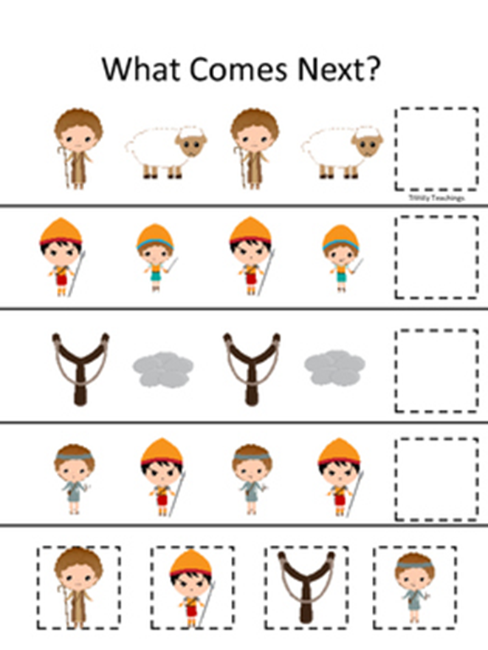
3 years to grade R


Grade 4 to 7

