
Week 9 – I am Called
Aim: Just like Father knew Samuel, Jesus knows your name, and Jesus still calls young and old today saying, "Come, follow me."

Scripture Reference: John10:27
Jesus said My sheep hear My voice I know them, and they follow me

Story:
watch YouTube Video on Samuel being called
https://youtu.be/CPMpycpDgFU

Can you imagine God came to you at night and gave you a special message and told you that he was going to give you an important job to do? Well, did you know that in some way God has done that?

Points to unpack:
Listening to God and doing what He commands us to do isn’t always easy. God might want you to stand up to someone who is doing something wrong, or to be a friend to someone who is lonely. God promises to be with us, especially during the most difficult things we could ever do.

We communicate with God through prayer when we talk to him and listen for his answers. Spend a little time in prayer telling God that you are listening for him and are waiting to be called by him to follow.
Listen for him to call you into something that is his will for you. God may not speak to you directly, or you may hear God while you pray to him or when you read the Bible.
Maybe God will call you to stand up for someone who is hurting. Or, maybe he will tell you to stop doing something that is not good for you and to spend more time following him instead. Whatever God calls you to, go for it, knowing that he will be with you every step of the way.

Prayer time:
Encourage the kids to pray for each other/ask for prayer. If they feel comfortable, they can tell you some of their fears that they want to give to God otherwise you can just ask them to think about their fears and lead them in prayer.
Thank you, Father, today we are listening for Your call. Perhaps You have something special for us to do. When You call, we will answer, "Here I am." In
Jesus’ name, amen.

3 Years to grade R 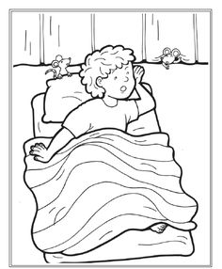

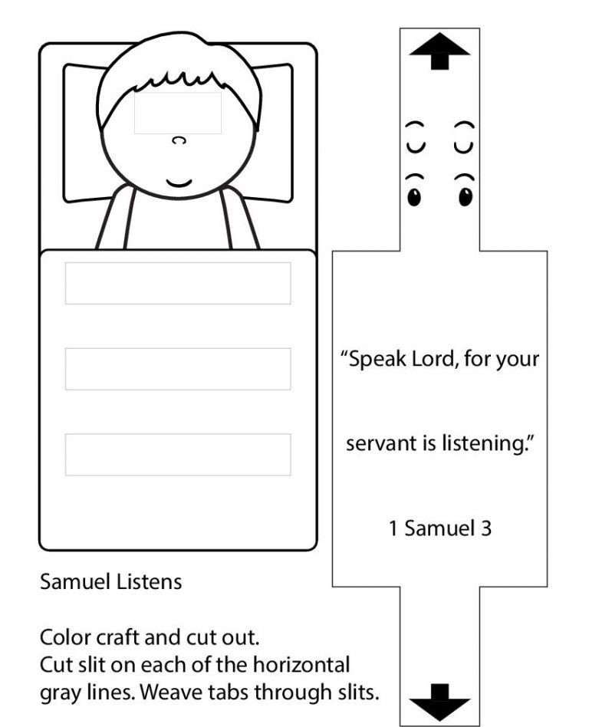

Grade 4