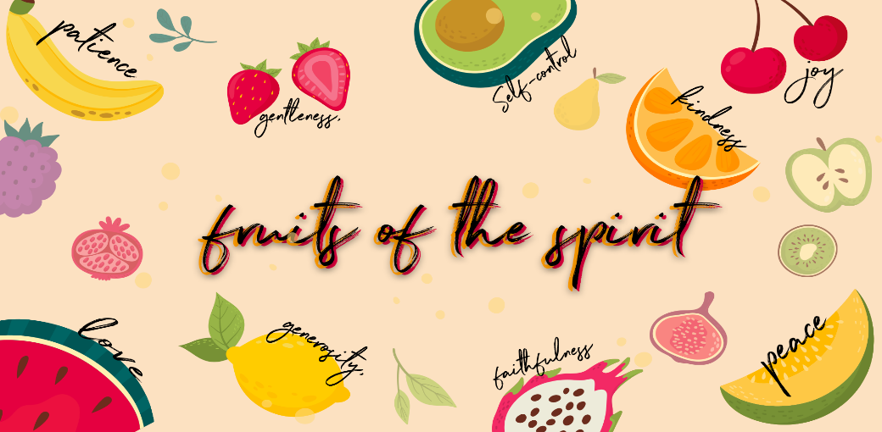

Checking in – Please check in with them about how their week has been, have they celebrated something this week? Such a good way to connect with them right from the start Then at the end of the lesson let’s pray about the things they may be struggling with and let’s thank Jesus for the things that were celebrated and good!
Recap
Who can remember what we learned about last week? Yes, love is the first and most important fruit of the spirit.
Love in action is such a beautiful thing!
This week we are learning about the second fruit of the spirit, can you remember what it is? JOY!
Let’s sing a song together about Joy! (I’ve got the joy, joy, joy, down in my heart…)
The bible tells us that when God is in our lives, there is a great joy! Do you know that we can choose to have joy? When we choose joy and laughter, we are claiming our territory in the kingdom. Proverbs 17:22 tells us that laughter is good for us!
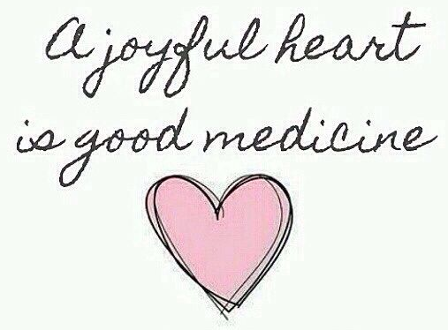

Joy & Happiness are not the same…
What are some of the things that make you happy? Talk about things that make children happy e.g., toys, money, sweets, movies, x-box, holidays, etc.
We generally feel happy when things are going the way we want, when we have something in our possession we really want, or when we are doing an enjoyable activity. When people say they are happy they are often looking forward to having fun, or they have recently experienced something pleasurable like eating a treat, playing with friends, or going somewhere exciting but Joy and happiness are not the same.

Happiness is an emotion or something we experience, but joy is a mind-set because we know God loves us and is always with us no matter what we are going through. The word Joy means cheerfulness, or gladness that is greatly multiplied. God’s joy is the bubbling up of delight – it doesn’t only come when something good or fun happens. It is His presence living in us that we feel. The Holy Spirit teaches us that God will never leave us. He listens to us like a friend. He protects us. He really understands us.

He is our joy, and the more we know Him, the greater our joy becomes. When we spend time with God, listening to worship music, reading His word, talking to Him, praying we get to know Him more and more and the fruit of joy is produced within us. We can experience joy even in times of sorrow. Joy is a choice.

For example… we feel happy when we are on our way to spend the day on the beach with friends. If it starts to rain, the feelings of happiness will turn into disappointment. If the plan must be changed, and we head back home instead, you may feel unhappy. But if you choose to make the most of the day, rather than be sad, you have chosen JOY! You may not be happy about the circumstances, but you choose to look beyond it and be joyful.

Object lesson

- A Balloon
- Baking Soda in a small packet
- A plastic water bottle filled to one-third of the way with vinegar
- A funnel
Explain to the children that the balloon represents them, and the bottle represents the Holy Spirit at work in their hearts.
Insert the funnel into the opening of the balloon, pour the baking soda into the funnel to fill the inside of the balloon explain that the baking soda represents spending time with God. Talk about ways we can do this—Reading His Word, Prayer, Worship, etc.
Attach the balloon to the plastic water bottle filled with vinegar. This person looks a little sad, just like the story of when the weather changed and we couldn’t go the beach, we had to go home, and we felt disappointment BUT then we decided to choose JOY instead and to make the most of our day!
Slowly lift the balloon and watch what happens next, the balloon will expand and fill with air… The Holy Spirit fills us with joy when we spend time getting to know God and being in His presence. Joy comes from being with God which means you can be joyful even in sad moments. Just like this balloon is standing up tall and is filled with JOY!
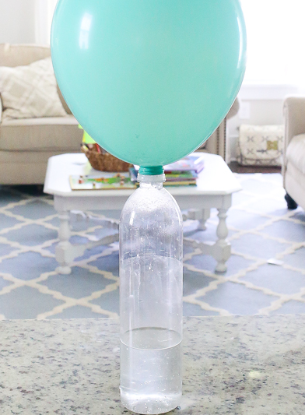
It is easier to choose joy when we are in a close relationship with God. Joy is a gift from God, and when we are friends with Him, he promises to fill us with joy! The bible says in Nehemiah 8:9 that “The joy of the Lord is our strength”. He gives us His joy to make us strong! We can be strong in all our situations, no matter what we face because we have His Joy in us. You can be full of joy even if you are not having a nice time because the Holy Spirit gives you the gift of joy. He can turn our bad times into great times if we trust him and we choose Joy. Just like the balloon stood up tall and was filled with JOY!

Pray together
- As you have connected and chatted to the children by checking in at the beginning and throughout the lesson, remember the specific situations the kids are going through.
- Please ask who would like to pray for their friends or who has a prayer request- invite them to share their needs & things that they are celebrating.
- This is such an amazing way to end the lesson before moving on to the craft!

Craft
Magnets
These cards are pre-cut in your boxes along with the happy face stickers.
The kids can colour in the cards and then stick on the happy face
There is magnetic tape in your boxes please cut and stick a strip across the back of theirs once they are done to create a magnet.

