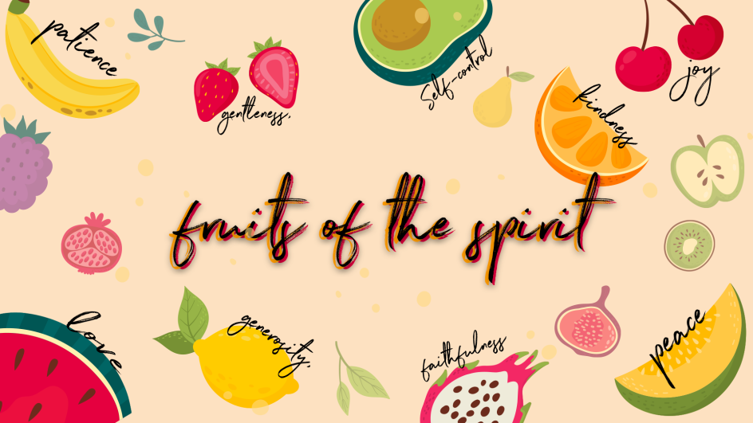
Love

Checking in – Please check in with them about how their week has been, have they celebrated something have they had a hard week? Such a good way to connect with them right from the start😊 Then at the end of the lesson let’s pray about the things they may be struggling with and let’s thank Jesus for the things that were celebrated and good!

Teaching

This term we are going to be learning about the Fruit of the Spirit!
Each fruit tree is different. Some soak up as much goodness from the sun and from the ground as they can. Those are the ones that have a lot more fruit. The bible teaches us that people produce fruit as well – have you ever heard of this?
Can you name some of the Fruit of the Spirit? The fruit of the Spirit is love, joy, peace, patience, kindness, goodness, faithfulness, gentleness and self-control.
In some ways we are just like fruit trees. Our fruit is the fruit of the spirit, which is the goodness of God growing in our lives. It shows that God is changing us to be more and more like him. When our roots are grounded deep in Jesus, we soak up His goodness. The Holy Spirit helps our fruit to grow as the sunshine of God’s love shines on us. Our lives should show many different kinds of fruit of the spirit every day.

The first Fruit of the Spirit is…. LOVE❤
There are many different kinds of relationships in which people love others. What are some examples of these? Parents love their children, Children love their parents, siblings, relatives (grandparents, cousins, etc.), friends and pets.
I have printed the following pictures (and popped them in your boxes) for you to show the children as you talk through this with them…
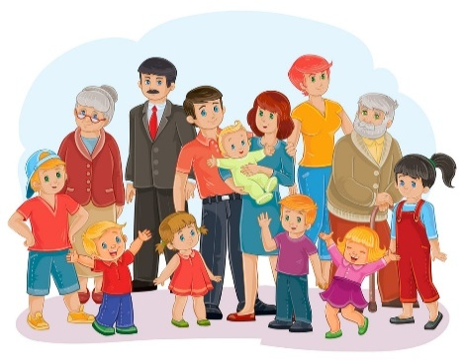 Family
Friends
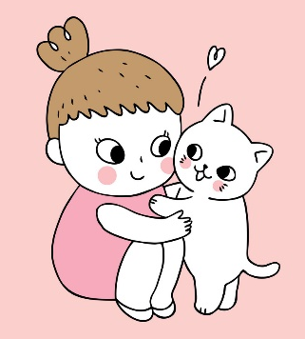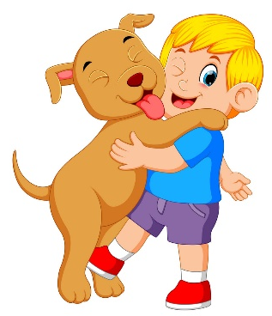Pets
Ask the children to share what they love about the people in their lives.
The Bible has a lot to say about love. It tells us that God loves us, and that God wants us to love him too. It tells us to love our neighbour – that is not just the people that live next door to us it is everyone that we know and meet.
There is so much in the Bible about love that some people call it a love letter.
A long time ago when Jesus was on earth, people thought the Bible was just about rules! Do this, don’t do that, say this, wear that, go here, worship there…
Rule after rule after rule. There was a lot about love, but there were so many rules that, that was all people cared about. But love was all Jesus cared about. He came here to show each one of us just how much He loves us. He loves us so much that He even died for our sins so that we can live with Him forever and always.
What the Bible says about love
1 Corinthians 13:4-8 says… Love is patient, love is kind. Love is not jealous, it does not brag, it is not proud. ⁵ Love is not rude, Love is not selfish, it is not easily angered. Love does not remember wrongs done against it. ⁶ Love does not delight in evil but rejoices with the truth. ⁷ Love always protects, always trusts, always hopes, always perseveres. ⁸ Love never fails.


Love is patient- We will go through hard things for people we love and sometimes it is difficult to wait for the things that we want, like when Mom is cooking dinner and we’re starving, we can be patient because we love our Moms and love is patient.

Love is Kind– Helpful, Generous & Good. We can be kind and share things with our friends because we love them.
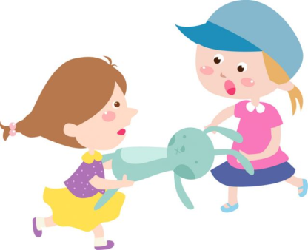
Love is not jealous– We don’t need to want what others have, we are happy when others are blessed. We rejoice for them because we have love in our hearts!

Love does not get angry quickly– Even when things go wrong, we can be patient and calm and not irritable.

Object Lesson
The greatest example of love is the love that God shows us. The word “Agape” in the bible, is another word for love, and it means that there is an endless supply of love! This is like food at a feast that never runs out! Let’s do a fun activity to see what love looks like…
I have packed the following in your boxes, for this object lesson:
- 2 glasses
- A small bucket
- A sponge
- Fill the bucket with water before the lesson, turn the bucket around so that they don’t see the sign on the front that says “God’s Love”.
- Dip the sponge in the bucket once, so that it is full of water, and set it aside.
- Set out one clear glass. Explain that the glass represents someone that you love.
- Hold up the sponge. Explain that the sponge represents the love in your heart.
- Squeeze as much water from the sponge as you can, into the glass. This represents when we show love to others.
- Hold up the glass so everyone can see how much water is in it now. Discuss the amount of water with the kids, is it half full? Is it enough “love”?
- Put the first glass down on the table again and put the second empty glass next to it.
- Pick up the sponge and ask the kids how much water they think you’ll be able to get in the second glass.
- Now, pick up the bucket and bring it to the table. Turn it so that the kids can see the sign on the bucket – and be sure to point out the sign to them😊
- Now you can dip the sponge as many times as you need to in the bucket and squeeze as much water as possible into the second glass.
- When the glass is full and overflowing, you can stop adding water.
- Ask the kids to compare the amount of water in the two glasses. Ask them to tell you which worked better–trying to squeeze water out of just a sponge, or dipping freely in the bucket first and then squeezing into the glass?
Explain to the kids that, when we dip into “God’s Love,” we are able to give a lot more “love” to someone else. God is love, and He is the source of love because of Him we are able to love at all times, even when it is hard for us sometimes! It is never hard for Jesus❤
Pray together
- As you have connected and chatted to the children by checking in at the beginning and throughout the lesson, remember the specific situations the kids are going through.
- Please ask who would like to pray for their friends or who has a prayer request- invite them to share their needs & things that they are celebrating.
- This is such an amazing way to end the lesson before moving onto the craft!

Craft
3 years to grade R
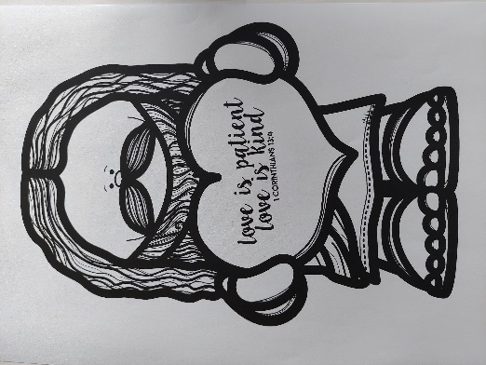

Grade 1-3
