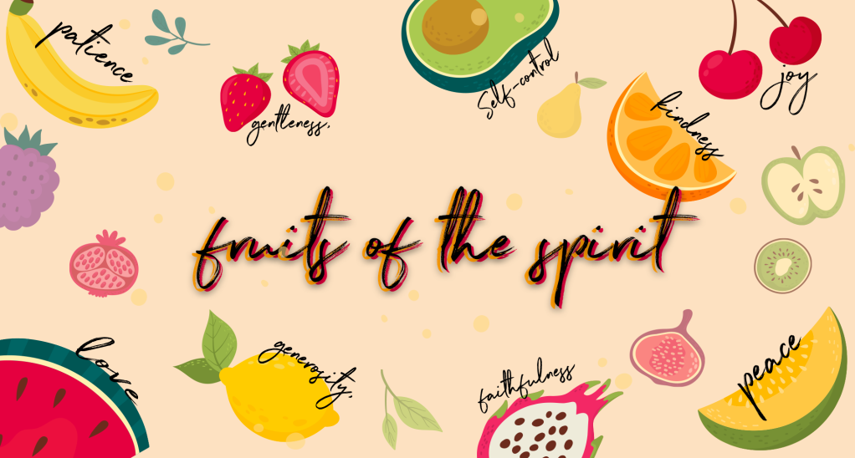

Love

Checking in – Please check in with them about how their week has been, have they celebrated something have they had a hard week? Such a good way to connect with them right from the start😊 Then at the end of the lesson let’s pray about the things they may be struggling with and let’s thank Jesus for the things that were celebrated and good!

Bible Verse
Matthew 22:37-40 - Jesus said, “LOVE the Lord your God with all your HEART and with all your SOUL and with your entire MIND. This is the first and greatest commandment. And the second is like it: LOVE your NEIGHBOR as yourself. All the Law and the Prophets hang on these two commandments.”

Teaching
This term we are going to be learning about the Fruit of the Spirit!
Each fruit tree is different. Some soak up as much goodness from the sun and from the ground as they can. Those are the ones that have a lot more fruit. The bible teaches us that people produce fruit as well – have you ever heard of this?
Can you name some of the Fruit of the Spirit? The fruit of the Spirit is love, joy, peace, patience, kindness, goodness, faithfulness, gentleness and self-control.
In some ways we are just like fruit trees. Our fruit is the fruit of the spirit, which is the goodness of God growing in our lives. It shows that God is changing us to be more and more like him. When our roots are grounded deep in Jesus, we soak up His goodness. The Holy Spirit helps our fruit to grow as the sunshine of God’s love shines on us. Our lives should show many different kinds of fruit of the spirit every day.
The first Fruit of the Spirit is…. LOVE❤
There are many different kinds of relationships in which people love others. What are some examples of these? Parents love their children, Children love their parents, siblings, relatives (grandparents, cousins, etc.), friends and pets. Ask the children to share what they love about the people in their lives.
The Bible has a lot to say about love. It tells us that God loves us, and that God wants us to love him too. It tells us to love our neighbour – that is not just the people that live next door to us it is everyone that we know and meet.
There is so much in the Bible about love that some people call it a love letter.
A long time ago when Jesus was on earth, people thought the Bible was just about rules! Do this, don’t do that, say this, wear that, go here, worship there…
Rule after rule after rule. There was a lot about love, but there were so many rules that, which was all people, cared about. But love was all Jesus cared about. He came here to show each one of us just how much He loves us. He loves us so much that He even died for our sins so that we can live with Him forever and always.
Bible story
Let’s read a story to see what Jesus says about love…
There were a whole bunch of people who really liked Jesus’ message of love, but there were also a bunch of people who really liked the rules. They thought following the rules was all that mattered, but they forgot that everyone makes mistakes sometimes and disobeys those rules and then what?!? Is that it? One broken rule and it’s all over? No way! Jesus came so that even when we make mistakes, He still loves us. It’s such an amazing way to show just how much He truly loves us.
One day the rule followers wanted to know what Jesus thought the most important rule of all was. “If we could only ever follow one single rule, which one would it be?” They expected Jesus to say one of the 10 Commandments - like obeying your parents, or do not steal, but Jesus had an even better one. The best rule of all and it’s all about love❤
Jesus said, “LOVE the Lord your God with all your HEART and with all your SOUL and with your entire MIND. This is the first and greatest commandment. And the second is like it: LOVE your NEIGHBOR as yourself. All the Law and the Prophets hang on these two commandments.” – Matthew 22:37-40
Jesus turned all of those rules into just two simple ones.
LOVE God and LOVE others❤
When you do not steal things, that’s a way of loving Him. When you obey your parents, that’s a way of loving them. Every single rule can fit into one of those two, it is so simple.
Now what do you think it means to love God with all your heart, soul and mind? It really just means that you love Him completely, all the time and in every way. The way we live our lives, the things we do and the way we love others – when we do all these things with love we show how much we love God.

Object Lesson
The greatest example of love is the love that God shows us. The word “Agape” in the bible, is another word for love, and it means that there is an endless supply of love! This is like food at a feast that never runs out! Let’s do a fun activity to see what love looks like…
I have packed the following in your boxes, for this object lesson:
- 2 glasses
- A small bucket
- A sponge
- Fill the bucket with water before the lesson, turn the bucket around so that they don’t see the sign on the front that says “God’s Love”.
- Dip the sponge in the bucket once, so that it is full of water, and set it aside.
- Set out one clear glass. Explain that the glass represents someone that you love.
- Hold up the sponge. Explain that the sponge represents the love in your heart.
- Squeeze as much water from the sponge as you can, into the glass. This represents when we show love to others.
- Hold up the glass so everyone can see how much water is in it now. Talk with the kids about the amount, is it half full? Is it enough “love”?

- Put the first glass down on the table again and put the second empty glass next to it.
- Pick up the sponge and ask the kids how much water they think you’ll be able to get in the second glass.
- Now, pick up the bucket and bring it to the table. Turn it so that the kids can see the sign on the bucket – and be sure to point out the sign to them😊
- Now you can dip the sponge as many times as you need to in the bucket and squeeze as much water as possible into the second glass.
- When the glass is full and overflowing, you can stop adding water.
- Ask the kids to compare the amount of water in the two glasses. Ask them to tell you which worked better–trying to squeeze water out of just a sponge, or dipping freely in the bucket first and then squeezing into the glass?
Explain to the kids that, when we dip into “God’s Love,” we are able to give a lot more “love” to someone else. God is love, and He is the source of love because of Him we are able to love at all times, even when it is hard for us sometimes! It is never hard for Jesus❤
Pray together
- As you have connected and chatted to the children by checking in at the beginning and throughout the lesson, remember the specific situations the kids are going through.
- Please ask who would like to pray for their friends or who has a prayer request- invite them to share their needs & things that they are celebrating.
- This is such an amazing way to end the lesson before moving onto the craft!

Craft
Heart envelope love letters… Please see instructions below on how to fold the heart into an envelope shape. The children can choose which patterned paper they would like, cut out their heart and then fold their heart - there are pre-printed lines for the kids to fold onto create the envelope. Let the children write a note to someone they love and seal it with a heart sticker, there is enough for them to make 2 or 3 each if they would like to – everything you need is in your box😊
