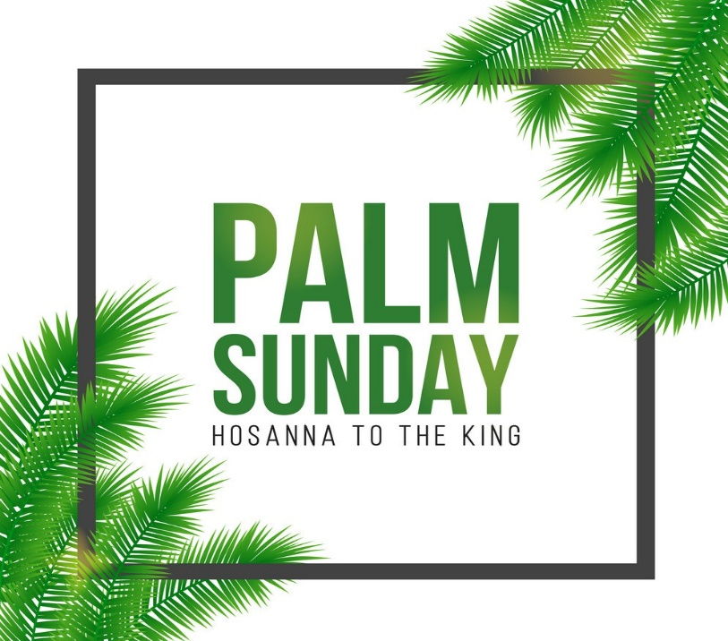

The Triumphal Entry

Bible Story: Jesus rides into Jerusalem on Palm Sunday.

Scripture: John 12:12-19

Palm Sunday celebrates the triumphal entry of Jesus into Jerusalem, just a few days before His betrayal and execution. On Palm Sunday, people celebrated Him and cheered, calling for salvation. The waiting was over – the promised King was finally coming into Jerusalem and the people crowded the streets to cheer his arrival.
Remember how he had travelled all over Israel helping people, doing miracles, and telling them about God’s love. Now he was coming to the capitol, the most important city. This was something the Bible had been promising for hundreds of years. It was all finally coming together, and the people were going crazy like they had just won the world cup.
Jesus was fulfilling prophecy. He was supposed to ride on a donkey’s colt – that means a young donkey. Can you imagine a big important king riding on a simple little donkey? What about the big army and the fancy horse? You see Jesus wasn’t a normal king trying to show he was important and force everyone to serve him. Jesus was the opposite: He came to show love and serve the people.
A big crowd was already showing up and covering the street with their coats and branches from the trees. Remember that they didn’t have paved roads back then – the roads were dirt. They were showing their respect to Jesus by covering the road so that He wouldn’t get dirty.
Jesus made quite an entrance! People were trying to figure out who He was. Remember, there was no television back then. People had heard about Him, but they had never seen Him before. Notice – they didn’t say that He was the Son of God. They called Him a prophet. It was difficult for some of the people of Jesus’ time to realize that He was God and that He was going to save them. Even his disciples would be confused and abandon Jesus later that same week.

Palm Sunday is the day that Jesus’ rode into Jerusalem on a donkey, to the shouts of “Hosanna! Blessed is he who comes in the name of the Lord!” It was a celebration because people knew that Jesus was coming to rescue them from their sins.
Kids love Palm Sunday because it’s such an exciting story–Jesus returning home in triumph and welcomed by cheering crowds! It’s a reminder that no matter what might be happening in our lives, God is always with us and will never leave.

Watch YouTube Video- https://youtu.be/z-39h0xYqdE
Game:
ITEMS NEEDED:
Palm branches
A soccer goals
Balloons
INSTRUCTIONS:
Choose one kid for this game. The kid will have 60 seconds to get two balloons into the soccer goal by fanning them with the palm branch. The balloons don’t have to stay in the goal; they just need to cross into the goal for each one to score a point. If the player can get two goals scored before time runs out, they win.

Prayer
Thank you, Father, as we celebrate Palm Sunday help us to remember that day when all the adults and children waved palm branches and cheered as Jesus entered Jerusalem as King. We know Jesus rose from the dead and is alive. Help us to remember that he is our wonderful King and that we can praise him every day! In Jesus’ name – Amen.

3 years to grade R Handprint palm tree
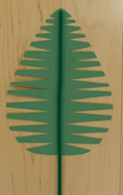 Grade 1 to 3 palm leaf fold n cut

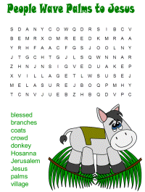 Grade 4 to 7-word search

