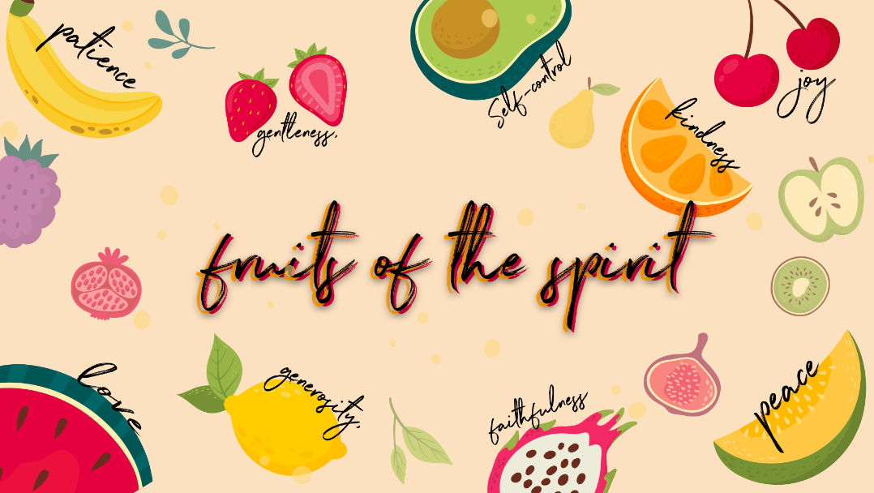

Goodness

Registration – please mark off the register with the kids, this is a great opportunity to learn their names & fill in missing info especially their birthdays!
Checking in – Please check in with them about how their week has been, have they celebrated something have they had a hard week? Such a good way to connect with them right from the start Then at the end of the lesson let’s pray about the things they may be struggling with and let’s thank Jesus for the things that were celebrated and good!
Recap
Who can remember what we learnt about last week? Yes, Kindness!
Kindness can be shown in our thoughts, our actions and our words. It is what we do, what we say and what we think! Kindness is the opposite of being selfish. It is our behaviour towards one another. The fruit of kindness allows us to be nice to everyone, even people who aren’t always kind to us.
Did you get an opportunity to be kind to anyone this week?
Were you able to bring something for the Hillside pantry to bless families in need?
This week we are learning about the sixth fruit of the spirit, do you know what it is? GOODNESS! Let’s quickly name all the fruit of the spirit together Love, Joy, Peace, Patience, Kindness, Goodness, Faithfulness, Gentleness & Self Control.
Lesson
When we think about Goodness, we think about what God is like. His goodness is like riches. The word goodness makes us think about things that are clean, virtuous and generous. God is good. He makes us more like Him when the fruit of the Holy Spirit is growing in us. Good is the opposite of bad. We learn goodness when we understand the difference between what God says is good and what He says is bad. When God calls something good, it will always make us stronger and more like Jesus. When God calls something bad, it is only to protect us from being hurt.
The more we choose good the easier it is to recognize the difference between good and bad. It becomes natural to choose goodness. Good just feels right. Bad things don’t feel good. It may seem like fun but then a heaviness or sadness or panic starts to build inside us, and we know that what we are doing is not good and not pleasing to God.
Let’s play a game! Ball Toss
Have the children sat in a circle and toss a ball to another child and have them tell you some of the good and loving things that God does? (Here are a few examples)
- He sent his Son Jesus to take the punishment for our sins
- He gives us eternal life
- He forgives us
- He helps us
- He teaches us
- He changes our hearts
- He protects us
- He comforts us
- He takes care of us
- He heals us
- He created this beautiful world for us
You can also ask them what are the things that they know are good? E.g. Family, friends, their school, church etc.
Bible Story
Let’s read the story of creation together and learn about the very first couple Adam & Eve and about a choice that they made…
*In your boxes are the pictures below, I have included Prestik as well so that you can stick them onto your box lid as you tell the story!

In the very beginning of all things, God decided to create our world, starting with light. God said, “Hello Light!” He divided it into night and day. “You’re good!” God said.


Then God said, “Hello Sea! Hello Sky!” and a great space opened up, wide and deep and high. “You’re good!” God said.


Then God said, “Hello land!” and there splashing up through the oceans, came cliffs, mountains and sandy beaches. “Hello trees! Hello grass and flowers! And everything, everywhere burst into life! “You’re good!” God said.
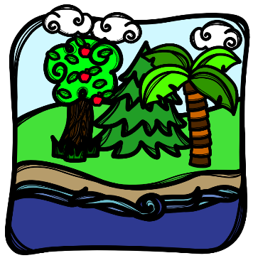
“Hello stars! God said. “Hello Sun! Hello Moon!” Whizzing into the darkness came fiery globes and whirling orange and purple planets and golden planets. “You’re good!” God said.

“Hello birds!” God said. Chirping and singing birds filled the sky. “Hello fish!” God said. With a darting and a splashing, fish filled the seas. “You’re good!” God said.
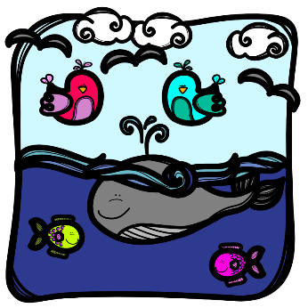
Then God said, “Hello animals!”. And everyone came out to play, the earth was filled with noisy noises, growling, and gobbling and happy scuffling. “You’re good!” God said.
God saw all that He had made, and He loved them. And they were lovely because He loved them. But God saved the best for last, from the beginning God had a shining dream in his heart. He would make people to share His forever happiness. So, God breathed life into Adam and Eve, and He said, “You are the most beautiful thing I have ever made and you look just like me!”
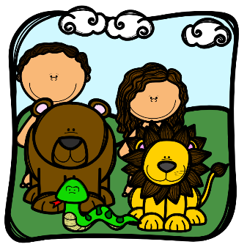
Well, one day Eve was walking in the beautiful garden and the serpent came and talked to her. He was really the enemy of God and was trying to trick Eve. When he asked her what she could eat, she told him that she could eat everything in the garden except for the fruit on one tree. Well this tricky enemy snake said that God didn’t want her to know the difference between good and evil and that, if she ate that fruit, she would be just like God!
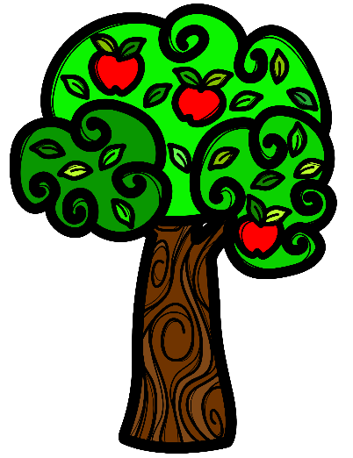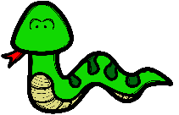
That’s when she started to look at the pretty fruit and decided that maybe it really was ok (Even though God said NO!)
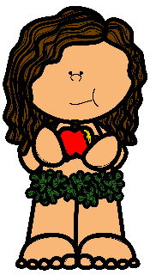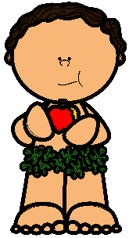
After she ate it, she gave some to Adam, but then they became ashamed. When God came to look for them, they were hiding.
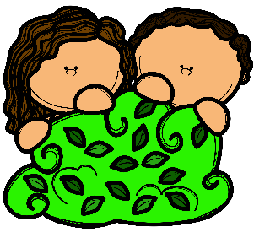
God heard the whole story and had to send them out of their wonderful garden to a life that was hard and not as good as their old life.
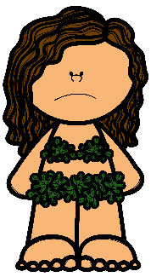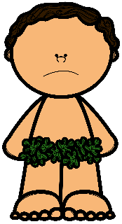
God wanted them to live without sin and evil. He gave them freedom to choose. When they ate the fruit, they knew about evil things. Fortunately, God had a plan. He was going to fix the problem of sin in this world, but it would cost a huge price. We know that He paid the price because of His great love for us. He sent His son Jesus to take all our sins on the cross.
Conclusion
Adam and Eve believed the lie of the enemy and he still lies to us today to get us to make bad choices BUT we can always trust God when we feel like we might be making a bad choice. We can ask for a word of wisdom to help us understand what is good or bad. It is a good idea to have such a close friendship with Jesus so that we can ask Him about the things that will help us or hurt us.
When God created all things his first comment was “It is good!” When God touches anything, it is always good. He spoke that word “Good” over us at the very beginning and that word is still over us and always will be God is good & loving to us all the time.
Scripture
Let’s look up Psalm 16:2 together… I say to the Lord, “You are my Lord; apart from you I have no good thing.”
Life is all about choices and thankfully we have the power of the Holy Spirit in us to help us to know what a good choice is and what is a bad choice. As we grow in goodness, we get to reveal what God is like to those around us.
Pray together
- As you have connected and chatted to the children by checking in at the beginning and throughout the lesson, remember the specific situations the kids are going through.
- Please ask who would like to pray for their friends or who has a prayer request- invite them to share their needs & things that they are celebrating.
- This is such an amazing way to end the lesson before moving onto the craft!

Craft
Babies to Grade 3
A picture to paint! I have printed this on cardboard and included paint, paint brushes & cups in your boxes.
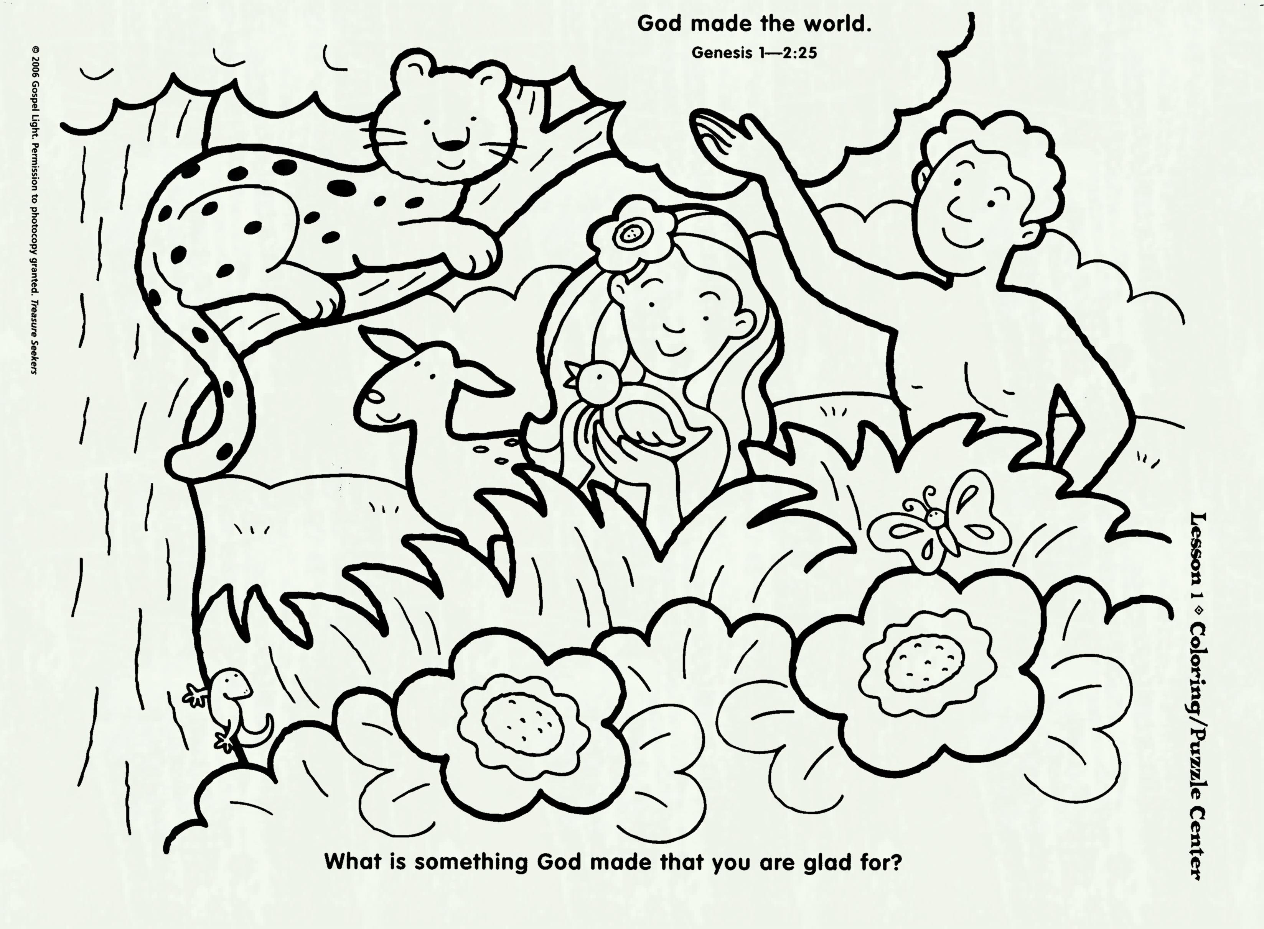
Grade 4 to 7
Have the kids cut out magazine pictures and create a collage that shows God’s goodness and the goodness in us and around us. Have them think of creation and how God is good and loving to us and to think about the things we chatted about during the ball toss game.
Magazines and cardboard will be in your boxes.

