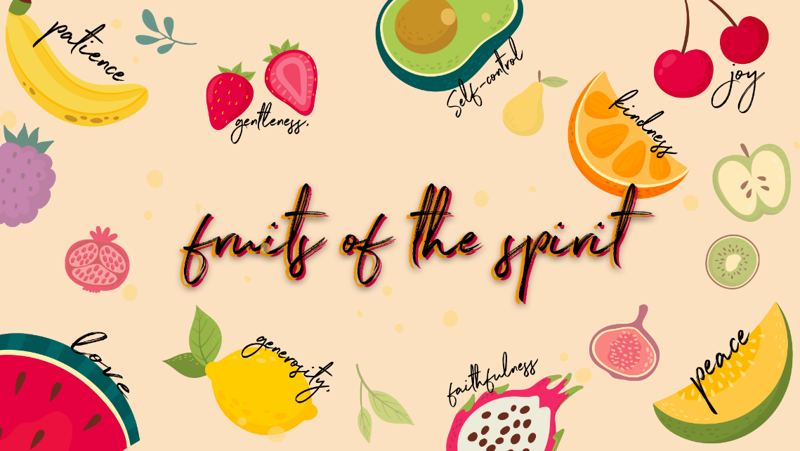

Patience

Checking in – Please check in with them about how their week has been, have they celebrated something have they had a hard week? Such a good way to connect with them right from the start Then at the end of the lesson let’s pray about the things they may be struggling with and let’s thank Jesus for the things that were celebrated and good!
Recap
Who can remember what we learnt about last week? Yes, Peace!
Peace comes when we stop and remember God’s promises. We can have peace even when we are facing problems or when we are feeling afraid – not because of what we feel but because of what we believe. When we remember the truth about Jesus, we allow peace to be in our hearts, and then in our body. The bible says that He will keep us in perfect peace when our minds are on him, because we trust in Him. (Isaiah 26:3)
This week we are learning about the fourth fruit of the spirit, do you know what it is? Patience! Let’s quickly name all the fruit of the spirit together Love, Joy, Peace, Patience, Kindness, Goodness, Faithfulness, Gentleness & Self Control.
Lesson
Can anyone tell me what patience is? Allow the children to share. The dictionary tells us patience is the capacity to accept or tolerate delay, problems, or suffering without becoming annoyed or anxious.
What is the opposite of patience – it’s impatience!
Who likes eating pineapples? (Show them the picture of the pineapples, it’s in your folder) Can you eat a pineapple without peeling it first? No way, it’s spiky and it would hurt you if you ate the skin. So, you must exercise patience when your mom or Dad is peeling it for you.

What are some of the things you go through that make you impatient?
Some examples are:
- Waiting for the bathroom when your sibling is taking too long
- If your mom or Dad are late to fetch you from school
- If you are in line to play a game and you must wait your turn
- Waiting in line at the shops…
Scripture
Let’s look in the bible about what it says about patience…
Let’s turn to Colossians 1:9-11 together.
⁹ For this reason, since the day we heard about you, we have not stopped praying for you. We continually ask God to fill you with the knowledge of his will through all the wisdom and understanding that the Spirit gives, ¹⁰ so that you may live a life worthy of the Lord and please him in every way: bearing fruit in every good work, growing in the knowledge of God, ¹¹ being strengthened with all power according to his glorious might so that you may have great endurance and patience,
We have Holy Spirit in us giving us wisdom and understanding and the power to be patient. Does this mean we will be patient all the time? No, but the more we practise and ask Holy Spirit to help us the more patient we will become.
Let’s play a game!
- Separate the class into two teams, each team will get a pair of chopsticks, a tub of beads and two paper plates. Ask who would like a turn to play first. That person will sit at the table with two plates in front of them (on one plate empty the tub of beads & the other one will be empty), chopsticks in one hand and the other hand behind their back.
- The person with the chopsticks needs to move as many beads across to the other plate as fast as possible with their team cheering them on!
- It will be difficult and get frustrating for the person doing it and for their teammates it will take patience to pick up those little objects with chopsticks!
- Once they have moved a few across or you can use your phone to time each of them for example 30 seconds per person, then the next person from their team can play – please sanitise the chopsticks before they pass them on to their teammate. This will also take patience on their part!
- Once they have all had a turn count their beads and declare the winner.
Discuss how that felt…
-Was the activity difficult?
-Time-consuming?
-Did it require patience?

Conclusion
When we pray for certain things sometimes, we wait and don’t get what we were promised and sometimes we think God doesn’t want to give it to us! Or that God has forgotten, and we don’t believe that He will fulfil His promises – BUT everything in God’s time not ours, His timing is perfect, and He always delivers His promises right on time
During our time of waiting is when we grow stronger, and God loves what happens to us when we wait. If we want to be a runner, we need to practise and eat right and sacrifice to become strong & train our bodies to do what it should to prepare for a race. Runners practise when others are playing. It costs something to be the best and that’s where we are heading with our dreams. God wants us to be the best at what we love. Sometimes that means that things won’t be easy. Like peeling that pineapple sometimes it pricks us and hurts us when we are trying to peel it but when it’s peeled and ready to eat it is so worth the wait!
Pray together
- As you have connected and chatted to the children by checking in at the beginning and throughout the lesson, remember the specific situations the kids are going through.
- Please ask who would like to pray for their friends or who has a prayer request- invite them to share their needs & things that they are celebrating.
- This is such an amazing way to end the lesson before moving on to the craft!
Craft
Grade 4 to 7
Today we are painting pineapples!
