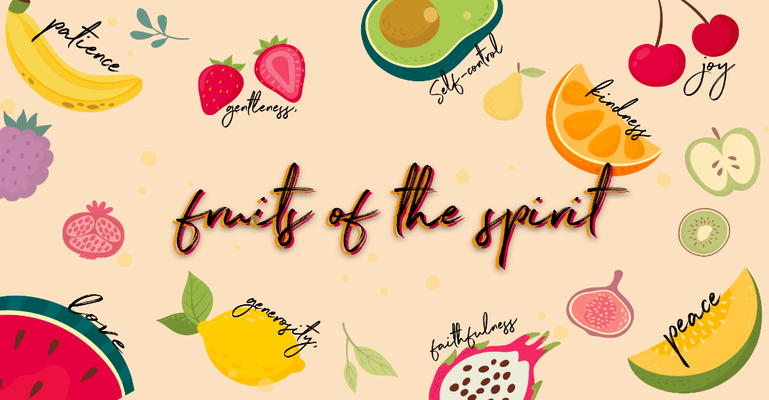

Checking in – Please check in with them about how their week has been, have they celebrated something, or have they had a hard week? Such a good way to connect with them right from the start Then at the end of the lesson let’s pray about the things they may be struggling with and let’s thank Jesus for the things that were celebrated and good!
Recap
Who can remember what we learnt about last week? Yes, joy!
Happiness is an emotion or something we experience, but joy is a mind-set because we know God loves us and is always with us no matter what we are going through. He is our joy, and the more we know Him, the greater our joy becomes. When we spend time with God, listening to worship music, reading His word, talking to Him, praying we get to know Him more and more and the fruit of joy is produced within us. We can experience joy even in times of sorrow. Joy is a choice.

Were you able to choose Joy this week? Ask the children if they have any stories or testimonies to share.
This week we are learning about the third fruit of the spirit, do you know what it is? PEACE! Let’s quickly name all the fruit of the spirit together Love, Joy, Peace, Patience, Kindness, Goodness, Faithfulness, Gentleness & Self Control.
Another word for peace is ‘rest’. We can try to calm and control everything around us, but we can’t control everything! There will always be things that happen that we can’t do anything about. So how do we have peace when things are spinning around us? Let’s read a bible story together about Jesus and his disciples and the day they were on a boat together…
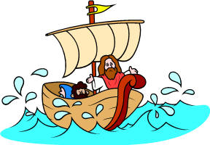
Bible Story

Jesus calms the storm Mark 4:34-40

One group will help by making the sounds of the sea as a giant storm comes through – there is a piece of blue fabric that the children can sit on and rock from side to side to be waves on or they can lift up the fabric together to create waves. The other group will pretend to be the frightened disciples in the boat – create a boat with chairs in rows. Someone can be Jesus sleeping in the boat to start. Who wants to be the sea and who wants to be disciples and who wants to be Jesus?

Show each group their role and allow them to practice.
- Group A (the sea)—These children will say “Swoosh, swoosh, swoosh” every time you point at them. Their chanting should gradually grow in intensity and then stop abruptly on cue!
- Group B (the disciples)—Kids will put their hands on their cheeks and cry out, “Oh me, oh my! This boat’s going to sink!”

Explain to the children… When I give you the signal by pointing to your group, you will act out your part of the story. Listen and watch for your part

One night after a long day of preaching to the people, Jesus decided to get into a fishing boat with his disciples. Leaving the crowd behind, Jesus and his friends got into the boat. Point to Group A. When they had sailed to the middle of the sea, a storm began to kick up waves. Point to Group A.
The boat rocked back and forth and up and down over the waves. The storm grew stronger and more furious. Group A should be getting louder now.
Jesus had fallen asleep almost as soon as the boat left the shore. Even though the sea was tossing the boat around, he was still asleep. But his disciples were beginning to get afraid. Point to Group B. They tried lowering the sail and throwing out the anchor, but nothing worked. Point to Group B. They bailed out the water, but still the storm raged. The boat was close to sinking. Point to Group B. Finally, they couldn’t stand it any longer. Jesus was still sound asleep, so they woke him up. They said, “Teacher, don’t you care if we drown?” Point to Group A and Group B.

With that, Jesus stood up in the boat and shouted out, “Peace! Be still!” Signal for everyone to be quiet. The wind died down, the waves grew calm, and the boat stopped sinking.
Jesus looked at his disciples, who were now soaking wet and shaking with fear. He said to them, “Why are you so afraid? Didn’t you believe that I would take care of you?”
The disciples were no longer afraid, but they were amazed. They turned to each other and asked, “Who is this? Even the wind and the waves obey him!”

Have kids applaud themselves for acting out the story so well.

What an exciting day that must have been for the disciples-first to be caught in that terrible storm and then to see Jesus take control of the weather and change it with only His words.

Jesus is the Son of God, creator of the universe. We can count on him to calm the storms in our lives. When a fear seems to take hold of us, we can call out to Jesus in prayer and know that he hears us just as he heard the disciples’ cries for help. When Jesus rebuked the wind with the word “Peace”, it was peace that calmed the wind. Calm replaced something scary and fearful.

Object Lesson

How Jesus calms our fears with His peace…
- Cup of vinegar
- Baking Soda
- Oil

Let’s do an experiment to see what happens when we let Jesus take care of our fears. Let’s pretend that the cup represents you. This white powder represents the things that scare us.
What are some of the things that scare you and how does it make you feel? Let the children each have a turn to share.
Is it wrong to be scared? No, definitely not.
Does Jesus want us to stay scared of something though? No way, He wants to reassure us that we don’t need to be afraid when we are facing the things that you all just shared. He wants to give us His peace.

Let’s pretend that the cup with the clear liquid in represents you and this white powder represents the things that scare us. The oil in this other cup represents Jesus.

Let’s see what happens when we add the things that we are afraid of into our hearts… (add the baking soda to the vinegar, it will bubble up fast!)
While you watch what happens, think about how you feel when you’re scared.
Quickly pour in the oil. Watch what happens and think about Jesus.

After the children have experienced the fizz of the baking soda and vinegar and the calming effect of the oil, invite them to share their reactions.
How was this experiment similar, to the way Jesus calms our fears?

Peace comes when we stop and remember His promises. We can have peace even when we are facing problems, or we are feeling afraid – not because of what we feel but because of what we believe. When we remember the truth about Jesus, we allow peace to be in our hearts, and then in our body. The bible says that He will keep us in perfect peace when our minds are on him, because we trust in Him. (Isaiah 26:3)

Pray together
- As you have connected and chatted to the children by checking in at the beginning and throughout the lesson, remember the specific situations the kids are going through.
- Please ask who would like to pray for their friends or who has a prayer request- invite them to share their needs & things that they are celebrating.
- This is such an amazing way to end the lesson before moving onto the craft!
Craft
This week we will be doing a Mother’s Day bible bookmark.

