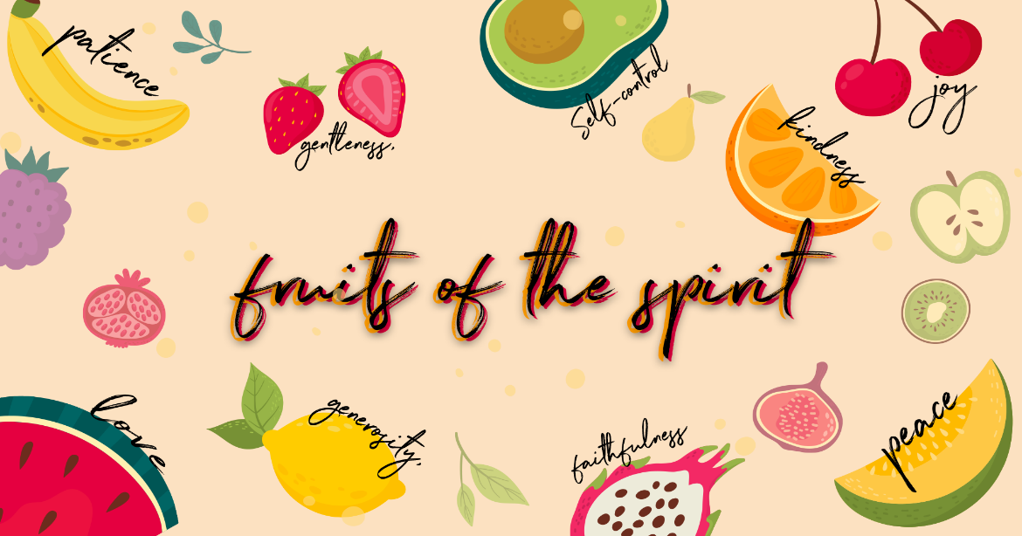
Faithfulness
Checking in – Please check in with them about how their week has been, have they celebrated something have they had a hard week? Such a good way to connect with them right from the start Then at the end of the lesson let’s pray about the things they may be struggling with and let’s thank Jesus for the things that were celebrated and good!
Recap
Who can remember what we were learning about last week? Yes, The fruit of the Spirit!
This week we are learning about the seventh fruit of the spirit, do you know what it is? Faithfulness! Let’s quickly name all the fruit of the spirit together Love, Joy, Peace, Patience, Kindness, Goodness, Faithfulness, Gentleness & Self Control & Goodness.
Lesson
What does it mean to be faithful?
To be faithful is to make a goal and stick to it no matter what happens. We can make promises easily, but to follow through on those promises requires us to be faithful to them. You can be faithful to a person (a friendship, family etc.), a cause (e.g. a charity organisation, a sports team), or a belief. Being faithful is all about not looking at other options in case this doesn’t work out.
Discussion
Talk to the children about being faithful.
How does it affect you when people are faithful in your world?
- Dad is faithful to his job – He gets paid a salary to have money to provide for your family and pay for your house, car, food etc.
- Mom is faithful to do the grocery shopping – There is food in your cupboards so that you can eat and not go hungry
- Your teacher is faithful to study and get ready for you – Your class goes well because your lesson is prepared for you
- The aeroplane pilot is faithful to get enough sleep – He will be able to think clearly and concentrate on the flight and you will have a safe flight
What would your life be like if these people weren’t faithful?
What happens in your world when you are faithful?
- When you brush your teeth?
- When you are a good friend?
- When you honour your parents?
- When you feed your pets?
- When you do your chores?
- When you pray?
- When you practise your sports, hobbies, instruments?
Bible Story
Who is the most faithful one of all? God
Let’s read a story together about God’s faithfulness…
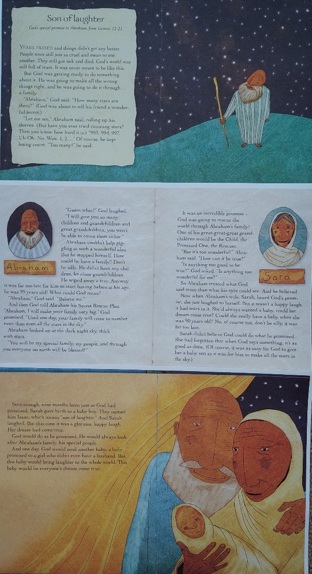
Abraham trusted God more than what his eyes could see. And he believed, it says so in the bible. Abraham was 100 and Sarah was 90, that’s really old that’s as old as your great granny and grandpa, can you imagine them having a baby? Even though he was really old, Abraham still believed and trusted Gods promise! Remember a promise is when you say that you are going to do something for someone, and you do it.
What are some of the promises that God has told you for your life? Are you trusting Him and believing Him for those promises to come true? Sometimes it’s hard to trust, like Sarah she didn’t believe that she could have a baby but look what happened when Isaac was born, she said “My dream has come true!” “I am so happy!”
Conclusion
God is faithful to us. He understands that we will make mistakes. He isn’t faithful because we are perfect. He is faithful to us because He loves us, and He made a decision to be patient and help us become everything He believes we can be.
Faithfulness is devotion to someone you love. God is devoted to us. He helps us be secure in our whole life because we know that He will never leave us. God is reliable. That means that if we need Him, He’s right there. We know that we are the most important things in the universe to Him and he is faithful to us so we can be secure!
Pray together
- As you have connected and chatted to the children by checking in at the beginning and throughout the lesson, remember the specific situations the kids are going through.
- Please ask who would like to pray for their friends or who has a prayer request- invite them to share their needs & things that they are celebrating.
- This is such an amazing way to end the lesson before moving onto the craft!
Craft
Abraham and the stars! For the babies everything has been cut out and glued down already – they can colour in Abraham and stick on the stars. For the Grade R’s and 1’s – they can glue down the green hill (these have been pre-cut), the scripture and their Abraham (there are some pre-cut Abrahams in your folder) and stick on the stars.
