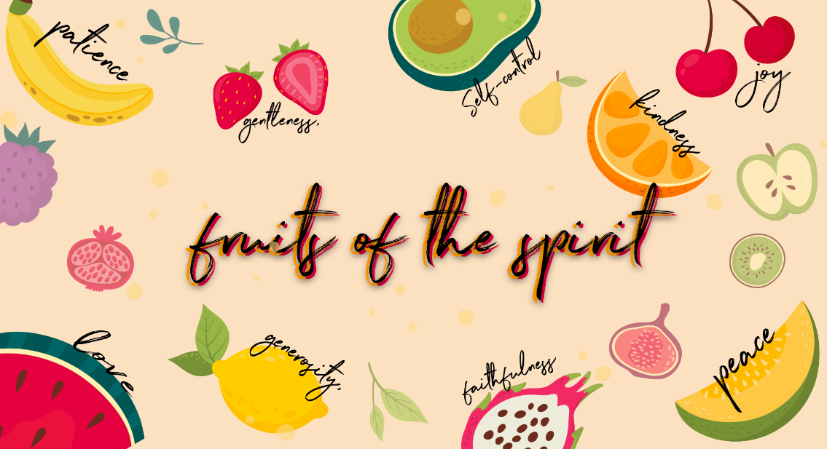
Gentleness
Checking in – Please check in with them about how their week has been, have they celebrated something have they had a hard week? Such a good way to connect with them right from the start Then at the end of the lesson let’s pray about the things they may be struggling with and let’s thank Jesus for the things that were celebrated and good!
Recap
Who can remember what we were learnt about last week? Yes, Faithfulness!
To be faithful is to make a goal and stick to it no matter what happens. We can make promises easily, but to follow through on those promises requires us to be faithful to them. You can be faithful to a person (a friendship, family etc.), a cause (eg. a charity organisation, a sports team), or a belief. Being faithful is all about not looking at other options in case this doesn’t work out.
This week we are learning about the eighth fruit of the spirit, do you know what it is? Gentleness! Let’s quickly name all the fruit of the spirit together Love, Joy, Peace, Patience, Kindness, Goodness, Faithfulness, Gentleness & Self Control & Goodness.
Lesson
The fruit of gentleness is about how we can be careful with one another and protect each other. Gentleness is realizing that we need to see each other as something or someone that can be hurt or bruised. Gentleness speaks of being careful with the hearts of each other. It is how we treat each other, not because we are helpless, but because we are valuable. The Holy Spirit is not harsh with us. He likes to play and laugh and dance over us. When His presence is strong, we feel peaceful. That is the gentleness of God covering us with His presence. We know that He is careful about how He treats us.

Treating others with gentleness
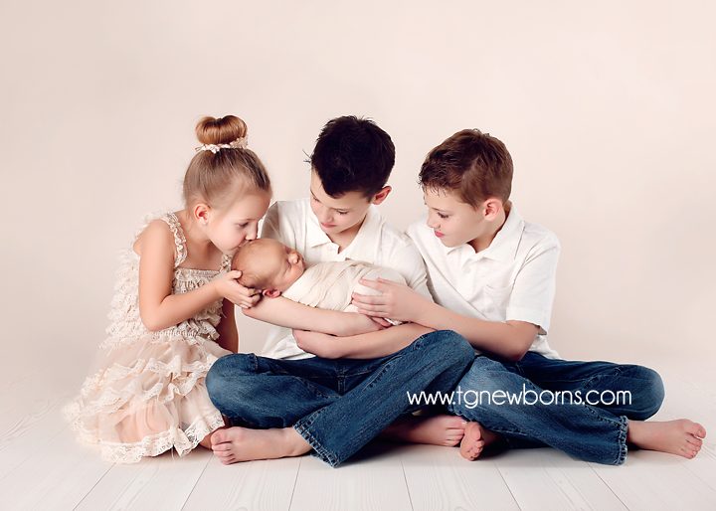
- Do any of you have a baby brother or sister?
- How do we handle babies?
- Look at this picture of a newborn baby with her brothers & sisters… (This picture is in your folders)
- Look how carefully they are holding her and loving her.
- Babies are fragile and we have to be careful with them. We are never rough with babies because it will hurt them. We treat them with gentleness.
We are gentle with things that are treasures to others. We don’t have to be careful with a plastic packet, but we do have to be gentle with Mom’s china tea cup. We protect things that are valuable. We feel safe with people who are gentle.
Gentleness is not just about how we care for a baby or precious things. God desires for us to be gentle in our actions, our words and our attitudes! Gentleness is not weakness, it is actually a term of delicate protection. Another word for this fruit is meekness – which is strength under control. Jesus was described as meek.
Object lesson
The following things will be in your box to be passed around and for the children to feel.
- Spoon - strong
- Feather - delicate
- Glass - delicate
- Tissue - delicate
- Plastic dish - strong
- Polystyrene cup - delicate
As the children are passing around the items let them hold each thing and talk about how careful they need to be with each one. Some things are strong and you don’t need to be careful with them. Other things are delicate and could get broken or damaged if you are not gentle.
The difference between harsh and gentle words…

There are rocks and pom poms in your boxes.

Ask the children to drop a rock (these are harsh words) on the floor or table and then have them drop the pom poms (these are gentle words) on the floor or table. Ask them what type of words they like to be spoken to them—harsh or gentle?

Talk together about how our hearts are very delicate and how we need to protect each others’ hearts from careless words or actions.

Pray together
- As you have connected and chatted to the children by checking in at the beginning and throughout the lesson, remember the specific situations the kids are going through.
- Please ask who would like to pray for their friends or who has a prayer request- invite them to share their needs & things that they are celebrating.
- This is such an amazing way to end the lesson before moving onto the craft!

Craft
Pom pom Caterpillar… who loves Caterpillars? They are such delicate little creatures, when we see them in our gardens, we must be very gentle with them, if we pick them up
We are going to make a caterpillar on a leaf! Everything you need is in your boxes.
